**Why opt for ManageEngine Endpoint Central**

With over 15 years of expertise in the IT management industry, ManageEngine Endpoint Central has understood the needs in the market, and developed the product to defend cyber-threats. Hence here are top 15 reasons to help understand why Endpoint Central is unique and on top of the endpoint management ladder.

* Endpoint Central enables you to **manage any device in your network from anywhere at any instant** with the most minimalistic and easy-to-use UI.
* Endpoint Central is [**compliant with major regulations**](https://www.manageengine.com/products/desktop-central/gdpr-compliance.html) like GDPR, PCI, CIS, ISO, VPAT, HIPAA and RBI compliance.
* **Network-neutral architecture** enables administrators to manage endpoints across Local Area Network, Wide Area Network, endpoints in Demilitarized Zone, and even closed network environment. Endpoints in different network environments like Windows Active Directory, Windows Workgroups, or Novell eDirectory are also supported.
* Endpoint Central enables **complete PC life cycle management** and management of on-the-go devices. The overall view of the network endpoints is given in the product dashboard.
* Provides complete end-to-end [**patching solution for Windows and other third party applications**](https://www.manageengine.com/products/desktop-central/patch-management.html#features). From detecting network vulnerabilities, testing and approving missing patches, to proceed with immediate patching solutions or **completely automate the patching process**, Endpoint Central provides a comprehensive patching solution.
* Over **50+ configurations and 200+ scripts across Windows, Mac and Linux** are available for the end-user to proceed with efficient device management.
* With [**6000+ predefined templates**](https://www.manageengine.com/products/desktop-central/software-deployment.html#a) available to deploy applications, software deployment is made simple with easily customization capabilities. The **Self-Service Portal** feature allows the end-user to choose to either install or uninstall the required application.
* The [**network assets will be continuously monitored**](https://www.manageengine.com/products/desktop-central/it-asset-management.html#features) through the data obtained by Inventory and file scan in Endpoint Central. The Enterprise can also **monitor the software usage** in the network and block applications whose usage is prohibited in the particular devices. The [**secure USB feature**](https://www.manageengine.com/products/desktop-central/control-usb-devices.html) will allow one to keep a look on the portable storage devices.
* To help the end-user and to resolve help-desk tickets which require technician support, one can use the [**in-built remote control tool**](https://www.manageengine.com/products/desktop-central/remote-desktop-software.html#features). Loaded with functionalities like**screen recording, voice and video call facilities, multi-technician support, and remote file transfer.** Endpoint Central paves a way for remote troubleshooting and seamless management.
* Endpoint Central can be[**integrated with prominent help-desk products**](https://www.manageengine.com/products/desktop-central/integration.html)like ServiceDesk Plus, ServiceDesk Plus Cloud, Jira, Zendesk, ServiceNow and Spiceworks to make the IT admin have transparent view of data across products. Other integration like Asset Explorer, Analytics Plus and Browser Security Plus is also supported by Endpoint Central.
* Endpoint Central can [**image and deploy OS**](https://www.manageengine.com/products/desktop-central/os-deployment.html)for a new machine through the OS deployment feature. In the current trend, Enterprises are looking for standalone OS deployment products to help in the **Windows 7 to Windows 10 migration process**. Customized deployment templates, hardware independent templates, and flexible boot options enable convenient OS deployment in Enterprises.
* Endpoint Central supports **modern management for Windows 10 and Mac devices.**
* Endpoint Central has over [**100+ out-of-the-box reports**](https://www.manageengine.com/products/desktop-central/desktop-management-reports.html) which will provide detailed insights on the actions performed in the endpoints. Custom reports can also be generated according to one's needs and preferences.
* An IT admin with the [**Endpoint Central mobile app**](https://www.manageengine.com/products/desktop-central/desktop-management-mobile-app.html) can manage all the endpoints from across the globe. One can deploy critical patches, obtain complete hardware and software reports and even take remote control of the endpoints in the network. [**Zia, the virtual assistant**](https://blogs.manageengine.com/desktop-mobile/desktopcentral/2019/03/19/meet-your-new-it-assistant-zia.html) in Endpoint Central can carry out all your tasks through voice recognition.
* Additional offerings like [**secure gateway service**](https://www.manageengine.com/products/desktop-central/secure-communication-of-mobile-users-using-forwarding-server.html)**,**[**fail over service**](https://www.manageengine.com/products/desktop-central/failover-server.html)**and**[**multi-language support**](https://www.manageengine.com/products/desktop-central/supported-languages.html) ensure efficient endpoint management of the network.

**A quick summary:**

ManageEngine Endpoint Central manages over 7 million endpoints with a happy customer base of 12,000+ organizations. We have over 85% of customers who renew the product annually. This is the number of satisfied customers who continue to trust ManageEngine's credibility and Endpoint Central's capabilities. With a complete endpoint management and security solution in place, rest assured that the Endpoint Central will watch over all the endpoints in the Enterprise.

# Setting Up Patch Management

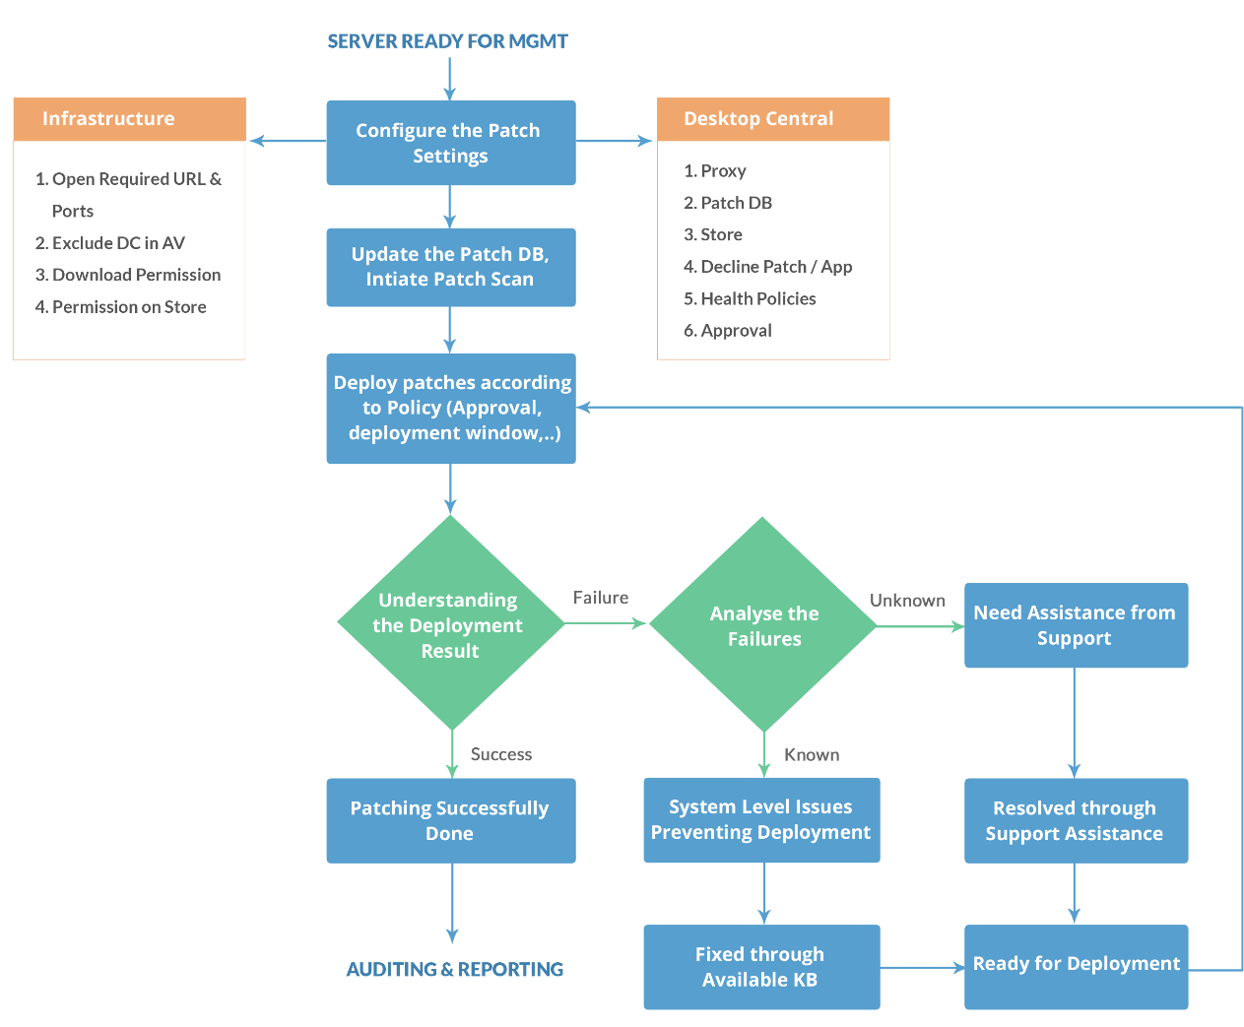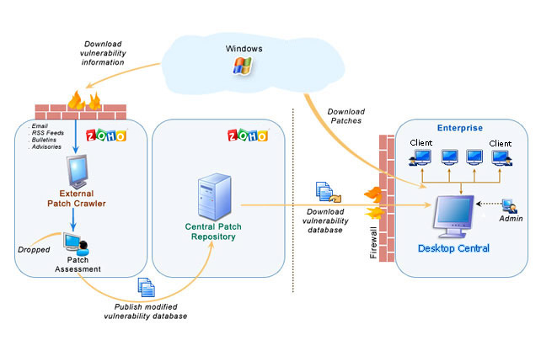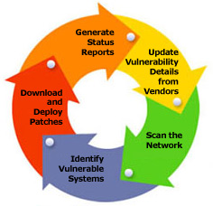

# Setting Up Software Deployment

enables you to deploy software remotely as well as distribute software applications to users and computers in a Windows network.

Package creation is the fundamental step in software deployment.

# Setting Up Asset Management

This section will guide you through the configurations that have to be performed to manage the software and hardware assets in your network.

* [Scan System for Inventory](https://www.manageengine.com/products/desktop-central/help/inventory/scan_systems_for_inventory.html#inventory-scanning)
* [Manage Software Licenses](https://www.manageengine.com/products/desktop-central/help/inventory/manage_software_licenses.html#Manage-Software-Licenses)
* [Create Software Groups](https://www.manageengine.com/products/desktop-central/help/inventory/create_software_groups.html)
* [Manage Software Category](https://www.manageengine.com/products/desktop-central/help/inventory/manage_software_categories.html#Manage-Software-Category)
* [Configure Prohibited Software](https://www.manageengine.com/products/desktop-central/help/inventory/configure_prohibited_software.html#Configure-Prohibited-Software)
* [Configure E-Mail Alerts](https://www.manageengine.com/products/desktop-central/help/inventory/configure_email_alerts_for_inventory.html#Configure-Email-Alerts)
* [Block Executable](https://www.manageengine.com/products/desktop-central/help/inventory/block_executables.html)
* [Schedule Inventory Scanning](https://www.manageengine.com/products/desktop-central/help/inventory/schedule_inventory_scanning.html#Schedule-Inventory-Scanning)

# Remote Desktop Sharing

The Remote Desktop Sharing feature enables administrators to access remote computers in a network. This Web-based feature enables you to access computers in both Local Area Networks (LAN) and Wide Area Networks (WAN).

# Endpoint Central configurations

Endpoint Central (formerly known as Desktop Central) offers configurations that help administrators manage applications, system settings, desktop settings, and security policies. These are extremely helpful in baselining systems and targets can be selected at user or system level. A group of configurations can also be applied together using the collection feature. The selected settings comes into action either during user logon or computer startup (depending on the type of configuration applied) to minimise the loss of productivity. Status of the applied configurations can also be tracked anytime.

1. [Defining configurations](https://www.manageengine.com/products/desktop-central/help/configurations.html#define-config)
2. [Applying configurations](https://www.manageengine.com/products/desktop-central/help/configurations.html#apply-config)
3. [Reverting configurations](https://www.manageengine.com/products/desktop-central/help/configurations.html#revert-config)

# Endpoint Central Tools

1. [Remote Control](https://www.manageengine.com/products/desktop-central/help/remote_desktop_sharing/remote_desktop_sharing.html)
2. [System Manager](https://www.manageengine.com/products/desktop-central/help/windows_system_tools/system_manager.html)
3. [Remote Shutdown](https://www.manageengine.com/products/desktop-central/help/windows_system_tools/shutdown_tool.html)
4. [Wake on LAN](https://www.manageengine.com/products/desktop-central/help/wake_on_lan_tool.html)
5. [Chat](https://www.manageengine.com/products/desktop-central/help/chat/chat.html)
6. [Announcement](https://www.manageengine.com/products/desktop-central/help/windows_system_tools/announcement.html)
7. [Windows System Tools](https://www.manageengine.com/products/desktop-central/help/windows_system_tools/windows_system_tools.html)

# Endpoint Central Reports

The following reports are offered by Endpoint Central:

1. [Scheduled Reports](https://www.manageengine.com/products/desktop-central/help/reports/scheduled_reports.html)
2. [Custom Reports](https://www.manageengine.com/products/desktop-central/help/reports/custom_reports.html)
3. [Query Reports](https://www.manageengine.com/products/desktop-central/help/reports/custom_query_report.html)
4. [Active Directory Reports](https://www.manageengine.com/products/desktop-central/help/reports/viewing_active_directory_reports.html)
5. [User Logon Reports](https://www.manageengine.com/products/desktop-central/help/user_logon_tracking/viewing_user_logon_reports.html)
6. [Power Management Reports](https://www.manageengine.com/products/desktop-central/help/reports/power_management/system_uptime_report.html)
7. [Configuration Reports](https://www.manageengine.com/products/desktop-central/help/reports/viewing_configuration_reports.html)
8. [USB Reports](https://www.manageengine.com/products/desktop-central/help/reports/usb_audit/usb_audit.html)
9. [Patch Reports](https://www.manageengine.com/products/desktop-central/patch-management-reports.html)
10. [Software Inventory Reports](https://www.manageengine.com/products/desktop-central/help/inventory/viewing_software_inventory_reports.html)
11. [Hardware Inventory Reports](https://www.manageengine.com/products/desktop-central/help/inventory/viewing_hardware_inventory_reports.html)

# Endpoint Central integrations

Endpoint Central integrates with several products that make the life of an IT administrator much easier, thereby dissolving the IT siloes seamlessly.

[Analytics Plus](https://www.manageengine.com/products/desktop-central/help-desk-integration.html?utm-source=help-landing-page#analytics-plus-integration): Get advanced insights on endpoints

[AssetExplorer](https://www.manageengine.com/products/desktop-central/help/configuring_desktop_central/integrating_with_asset_explorer.html?utm-source=help-landing-page): Procure software and hardware inventory details automatically

[Browser Security Plus](https://www.manageengine.com/products/desktop-central/browser-security-plus-integration-home.html?utm-source=help-landing-page): Secure and manage browsers centrally

[Freshservice](https://www.manageengine.com/products/desktop-central/freshservice-integration.html?utm-source=help-landing-page): Bolster your helpdesk with endpoint management

[Jira](https://www.manageengine.com/products/desktop-central/jira-integration-home.html?utm-source=help-landing-page): Solve issues in Jira at the click of a button

[ServiceDesk Plus](https://www.manageengine.com/products/desktop-central/help/configuring_desktop_central/dc_sdp_integration.html?utm-source=help-landing-page): Step up your ITSM game

[ServiceDesk Plus On-Demand](https://www.manageengine.com/products/desktop-central/help/configuring_desktop_central/integrating_with_servicedesk_plus_on_demand.html?utm-source=help-landing-page): Resolve helpdesk tickets right from cloud

[ServiceNow](https://www.manageengine.com/products/desktop-central/servicenow-integration.html?utm-source=help-landing-page): Centralize all your ITIL processes

[Spiceworks](https://www.manageengine.com/products/desktop-central/spiceworks-integration-home.html?utm-source=help-landing-page): Manage incidents seamlessly

[Zendesk](https://www.manageengine.com/products/desktop-central/zendesk-integration.html?utm-source=help-landing-page): Meet your SLAs faster than ever

# Setting Up OS Deployment

**Understanding OS Deployment**

* [Workflow](https://www.manageengine.com/products/desktop-central/help/configuring_desktop_central/osdeployment-workflow.html)

**Remote office**

* [Creating remote office](https://www.manageengine.com/products/desktop-central/help/configuring_desktop_central/creating-osd-remote-office.html)
* [Configuring OS Deployment settings](https://www.manageengine.com/products/desktop-central/help/configuring_desktop_central/remote-office-osd-settings.html)

**Imaging**

* [Imaging overview](https://www.manageengine.com/products/desktop-central/help/configuring_desktop_central/imaging-overview.html)
* [Online imaging](https://www.manageengine.com/products/desktop-central/help/configuring_desktop_central/creating-os-image.html)
* [Offline imaging](https://www.manageengine.com/products/desktop-central/help/configuring_desktop_central/offline-imaging.html)
* [Creating PE media](https://www.manageengine.com/products/desktop-central/help/configuring_desktop_central/creating-winpe-media.html)
* [Hardware independent deployment](https://www.manageengine.com/products/desktop-central/help/configuring_desktop_central/hardware-independent-deployment.html)

**Customizing deployment**

* [Creating deployment template](https://www.manageengine.com/products/desktop-central/help/configuring_desktop_central/customizing-image-deployment.html)
* [Post deployment activities](https://www.manageengine.com/products/desktop-central/help/configuring_desktop_central/configuring-post-deployment-activities.html)
* [Adding applications](https://www.manageengine.com/products/desktop-central/help/configuring_desktop_central/adding-applications.html)

**Deployment**

* [Deployment overview](https://www.manageengine.com/products/desktop-central/help/configuring_desktop_central/deployment-overview.html)
* [Deployment via tasks](https://www.manageengine.com/products/desktop-central/help/configuring_desktop_central/deploying-os-image.html)
* [Deployment via templates](https://www.manageengine.com/products/desktop-central/help/configuring_desktop_central/offline-deployment.html)
* [Booting and deployment](https://www.manageengine.com/products/desktop-central/help/configuring_desktop_central/associating-deployment-task-remote-office.html)

